Image Studio - Code Source

1- Image Studio - Ai Question - 1
# Source: Person Source: Provided by: [Data Path: Persons Table -> ID Column: 1, Name_En Column: Motasem Essam] Written by: [Data Path: Persons Table -> ID Column: 1, Name_En Column: Motasem Essam] on [6/17/2026]
- Give me project to view images
- Make me zoom and move through image
- Make me full screen size image
- Make me rotate image
- Make me crop image
- Make me undo and redo action in image
- Make me crate collage of images and save it
- Make me can make program as default app
- Add recent images

2- Image Studio - Ai Answer - 1
# Source: AI Source: Provided by: [Data Path: Persons Table -> ID Column: 1, Name_En Column: Motasem Essam] -> From: [ChatGPT] on [6/17/2026]
Project structure
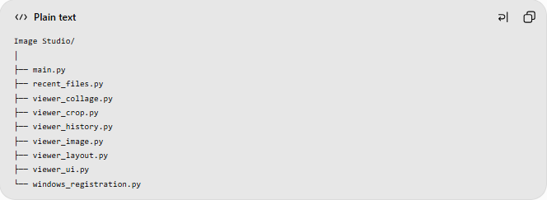
Image Studio/
│
├── main.py
├── recent_files.py
├── viewer_collage.py
├── viewer_crop.py
├── viewer_history.py
├── viewer_image.py
├── viewer_layout.py
├── viewer_ui.py
└── windows_registration.py

